Day 1 | 9.00 - 9.30am – Registration & Refreshments

Time | Topic | Speaker
09:30 | Chair’s Opening: Welcome and introduction from the FirePRO Chair | Jack Grasby (FirePRO Chair)
09:45 | Comms Rebel: Turning intention into impact by aligning people, purpose and performance through communication | Advita Patel (CIPR President)
10:30 | Fire Standards: Getting your help in reviewing your Communications and Engagement Fire Standard | Georgina Staley (NFCC Fire Standards Board)
11:15 | Break & Networking
11:30 | Raining On Your Parade: How we respond to the ‘endless’ negative comments on social media | Lucinda Hellon (Lancashire FRS)
12:15 | TikToking Around The Clock: Using data to inform our approach, changing risk profiles and how we respond | Jade Hammond (Essex FRS)
1:00 | Lunch & Networking
1:45 | FirePRO Awards: Exploring how we could celebrate and recognise excellence across the sector | Nathan Simmonds (WMFS)
2:15 | Artificial Intelligence: How individual services are using new technologies to boost productivity | Facilitated by Jack Grasby (Notts FRS) and Rachel Palmer (DFRS)
3:00 | Break & Networking
3:15 | UnConference: Shared problem solving, ranting and learning from others | FirePRO Committee
4:30 | Day One Close

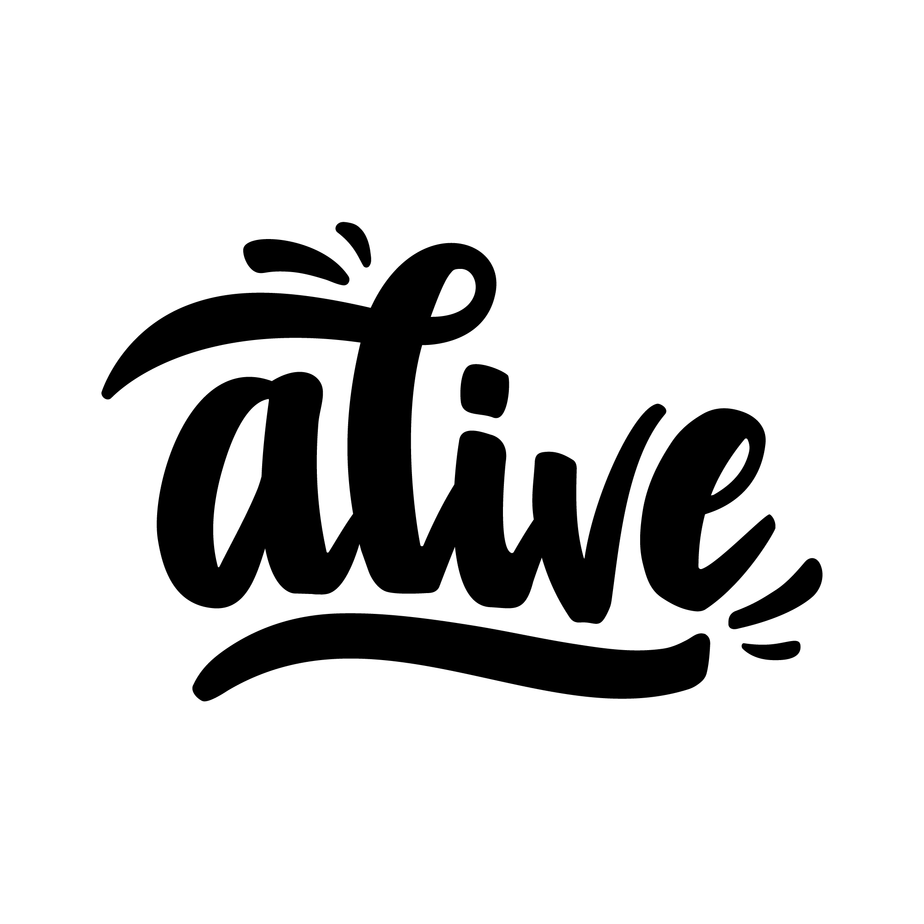
7pm – Drinks & Networking – Ashtead Foyer
8pm – Evening Street Food and quiz – Ashtead Suite
Huge thank you to our GOLD event sponsors this year!



Day 2 | 8.30 - 9am – Registration & Refreshments

Time | Topic | Speaker
9:00 | Day Two: Summary of the previous day learning, and welcome to our second day | Richard Edney (FirePRO Vice-Chair)
9:05 | Our Sector: Exploring the challenges, opportunities and priorities facing the sector, and the key role communications teams play in building understanding, trust and influence | Phil Garrigan (Chair, National Fire Chiefs Council)
9:50 | Emerging Comms Challenges: Workshopping influencers, enthusiasts and protective security issues | Facilitated by the FirePRO Committee
10:30 | Break & Networking
10:40 | Change Communications: What works for our people? The good, the bad and the ugly | Rachel Harper (Internal Comms Business Partner, Citizen Housing)
11:20 | Remote Colleagues: Targeting internal communications at on-call firefighters – our collective, age-old challenge | Maria Coyle (Internal Comms Lead – LFB & On-Call Firefighter – Surrey FRS)
12:00 | Lunch & Networking
12:45 | New Age Socials: Understanding the changing social media landscape and what it means for communicators | Facilitated by James Morton and CAN Digital
1:30 | Break & Networking
1:45 | Behaviour Change: A fast-paced session giving you evidence-based techniques you can apply straight away to increase the impact of your communications. | Russell Cartwright (Cartwright Training & Consultancy)
2:45 | Bicester Motion: Learning lessons from one of the most tragic incidents the FRS has seen in recent history. | Emily Highton (Oxfordshire FRS)
3:30 | Day Two Close – CPD Certificates

